**1)Traceroute google.com**

The traceroute command can be executed only in linux machines and the windows alternative for traceroute is tracert. The relevant outputs are attached below.

**Ping google.com**

In windows machine the ping command is performed to google.com and relevant outputs are presented below.

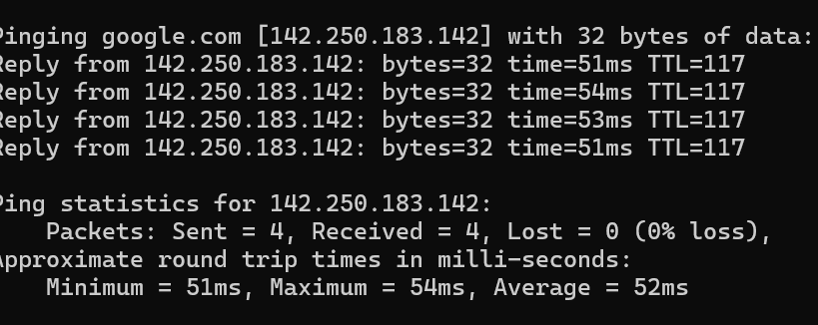

**2)** **Design a network with firewall and open ssh, http and https port.**

I have installed the **Uncomplicated Firewall (UFW)** on my Linux virtual machine and enabled the firewall. After enabling it, I verified the active ports in the firewall. Then, I added rules to allow **SSH**, **HTTP**, and **HTTPS** traffic using the following commands:

sudo ufw allow ssh

sudo ufw allow http

sudo ufw allow https

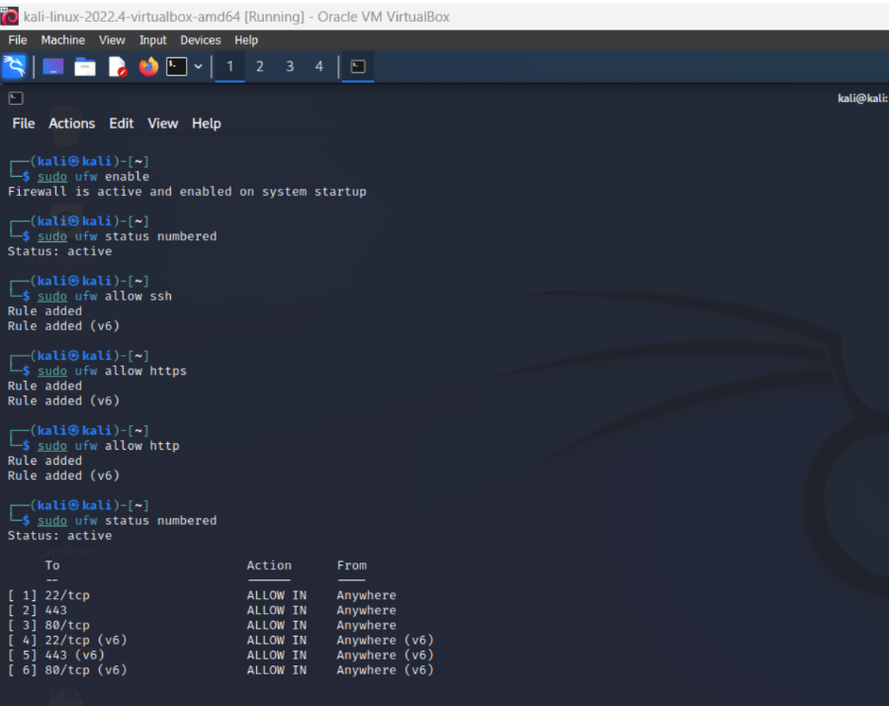

As shown in the picture we configured the rules for the firewall allowing specific ports such as SSH, HTTP, HTTPS 